NALCAB Summer in the States Social Media Toolkit

Why should my organization participate?
The purpose of this campaign is to raise the profile of the importance of community and economic development funding to Latino and low- and moderate-income communities.

When and how do I participate?
Post on social media anytime between August 6 and August 28, 2020! Use our infographics and sample posts below (organized by the program we’re targeting). All infographics have been optimized for both Twitter and Instagram, and can also be used on Facebook and Linkedin.

Should I use a specific hashtag?
Yes! #LatinoEconomicEngine

What should I post?
Click on the links below to see the infographics and sample social media posts for these federal programs!

Community Development Financial Institutions (CDFI) Fund

US Department of Housing and Urban Development (HUD) Affordable Housing programs

US Small Business Administration (SBA) Access to Capital and Entrepreneurship programs

Community Development Block Grant (CDBG) Program

US Department of Agriculture (USDA) Rural Housing and Development programs

Should I tag anyone?
Yes! Tag @NALCAB on Instagram, Facebook, and LinkedIn, @NALCABPolicy on Twitter, and your Senator (see list below). Since most budget bills have already passed through the US House of Representatives, we are focusing on the Senate for this campaign.

List of US Senators’ Twitter Handles

Community Development Financial Institutions (CDFI) Fund

Infographics: (CLICK HERE for high res version of graphics)
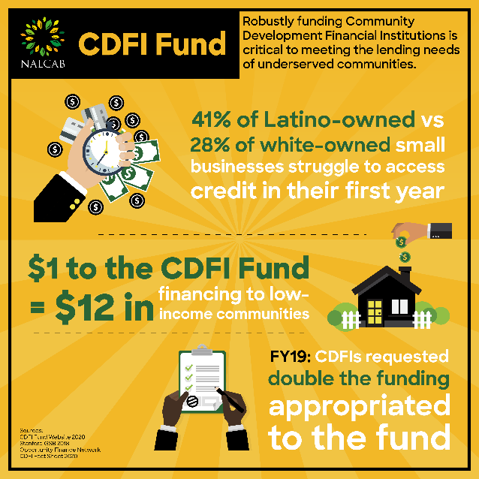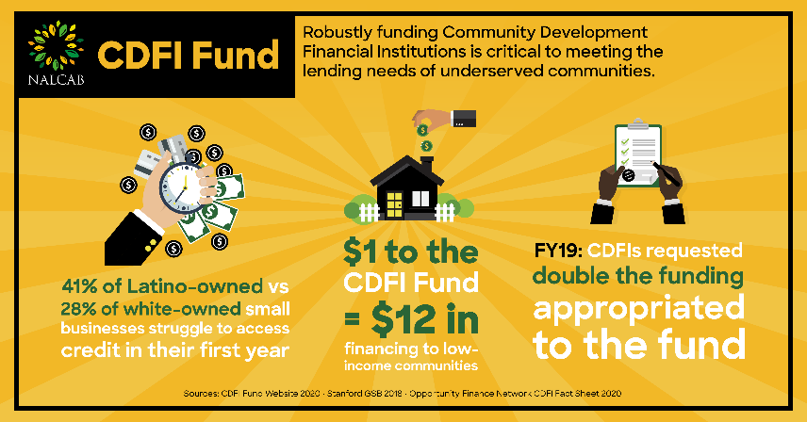
Sample Posts:
CDFIs are a lifeline for Latino communities- @YOURSENATOR show up for racial justice and fully fund the @CDFIFund at least $273.5M in FY2021! #LatinoEconomicEngine @NALCAB
CDFIs re-invest their money into the communities they work in. Support prospective homeowners & entrepreneurs in your state by fully funding the CDFI Fund at $273.5M! #LatinoEconomicEngine @NALCAB
Latinos start businesses at higher rates than other demographic groups, but struggle to access the capital they need to thrive. Invest in America’s future by fully funding the CDFI Fund at $273.5M and boost the economy! #LatinoEconomicEngine @NALCAB
CDFIs fill the financial services gap and uplift Latino communities nationwide. @YOURSENATOR- show up for Latino communities in YOURSTATE and appropriate $273.5M for CDFIs! #LatinoEconomicEngine @NALCAB

US Department of Housing and Urban Development’s Affordable Housing Programs

Infographics: (CLICK HERE for high res version of graphics)
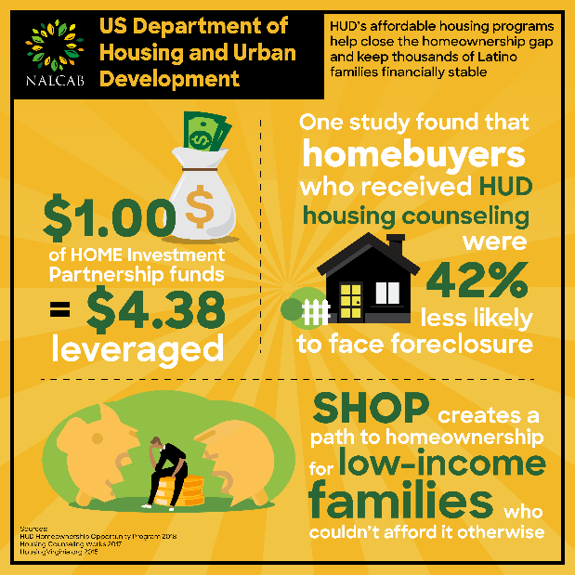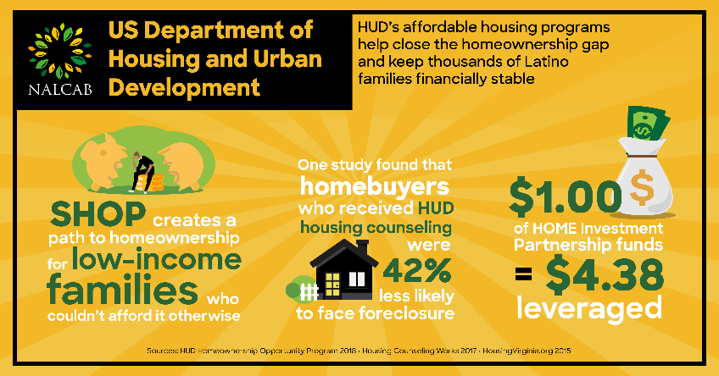
Sample Posts:
Affordable housing gives families the chance to climb the economic ladder and build wealth for the next generation. Fund HUD’s HOME program at $1.7B and SHOP program at $55M to ensure Latino prosperity for decades to come. #LatinoEconomicEngine @NALCAB
The COVID-19 crisis is creating a tidal wave of evictions across the nation. Affordable housing has never been more urgent- @YOURSENATOR fully fund HUD’s HOME program at $1.7B and SHOP program at $55M to stabilize American families! #LatinoEconomicEngine @NALCAB
Millions are losing sleep worrying about how to come up with rent. Affordable housing is critical to COVID-19 infection prevention and economic recovery- HUD’s affordable housing programs must be funded at HEROES Act levels to keep Americans safe! #LatinoEconomicEngine @NALCAB
Housing counseling helps to prevent foreclosures and keeps homeowners & renters financially stable. Allocate at least $100M to housing counseling in FY2021 to keep communities strong during COVID-19 recovery! #LatinoEconomicEngine @NALCAB

US Small Business Administration (SBA) Access to Capital & Entrepreneurial Development programs

Infographics: (CLICK HERE for high res version of graphics)
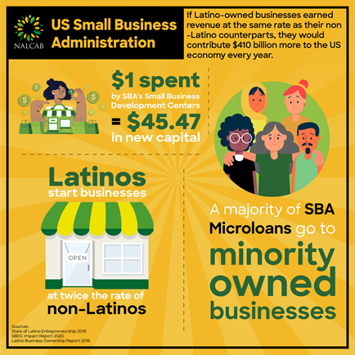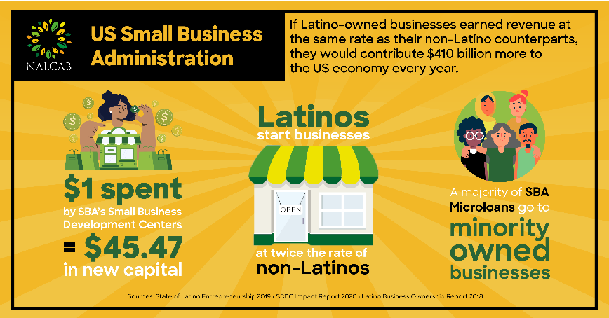
Sample Posts:
SBA’s PRIME & Microloan programs encourage minority participation in small business ownership. @YOURSENATOR fully fund them at $7M & $55M respectively to revitalize YOURSTATE’s economy & end racial disparities in business ownership! #LatinoEconomicEngine @NALCAB
SBA’s Microloan program keeps the most vulnerable small businesses stable and will be critical during COVID-19 recovery. Fully fund it at $55M to support minority-owned small businesses and kickstart our struggling economy! #LatinoEconomicEngine @NALCAB
Latino business ownership is one of the country’s biggest untapped sources of economic growth. @YOURSENATOR fully fund SBA’s Microloan program at $55M and PRIME at $7M to put STATENAME on the road to recovery! #LatinoEconomicEngine @NALCAB
Pre-COVID, Latino business ownership was growing faster than any other group. Let’s keep it up & give small businesses the resources they need to recover & flourish by appropriating $55M for SBA’s Microloan program & $7M for PRIME in FY2021! #LatinoEconomicEngine @NALCAB

Community Development Block Grant (CDBG) Program

Infographics: (CLICK HERE for high res version of graphics)
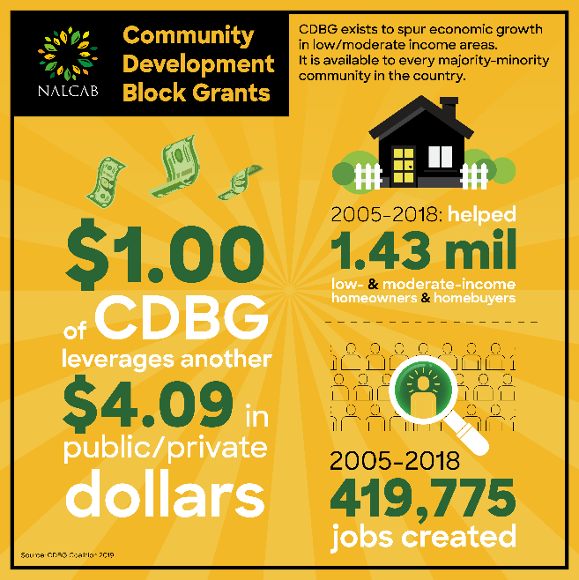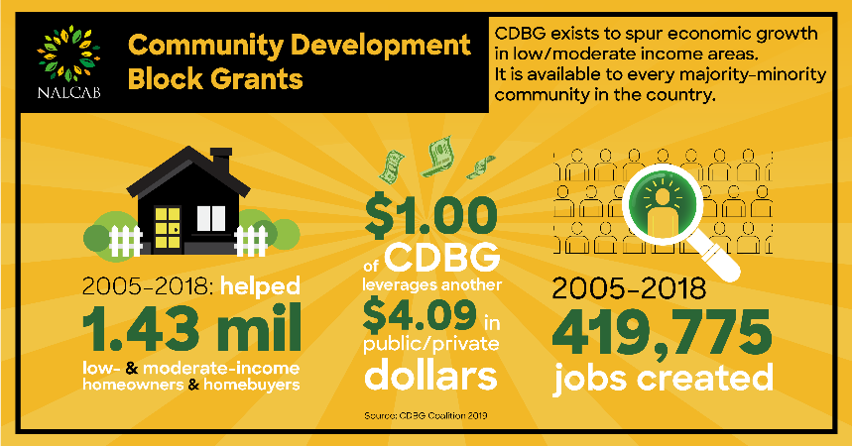
Sample Posts:
COVID-19 has been a wake-up call: we need to build strong, resilient communities that can weather any storm. @YOURSENATOR fund the CDBG program at $3.8B in FY2021 to boost long-term recovery across your state! #LatinoEconomicEngine @NALCAB
Decades of inequality have made it hard for Latino businesses, homeowners, & families to access the resources needed to build strong communities. @YOURSENATOR support racial justice and fully fund the #CDBG program at $3.8B in FY2021! #LatinoEconomicEngine @NALCAB
@YOURSENATOR: which federal funding stream is critical to minority communities & available in every Congressional district in the US? The #CDBG program-and it needs at least $3.8B in FY2021 to keep Latino communities stable! #LatinoEconomicEngine @NALCAB
Majority-minority communities have been hardest hit by COVID and the ensuing economic downturn. @YOURSENATOR combat the racial inequities that allowed this & fully fund the #CDBG program at $3.8B in FY2021! #LatinoEconomicEngine @NALCAB

US Department of Agriculture (USDA) Rural Housing and Development programs

Infographics: (CLICK HERE for high res version of graphics)

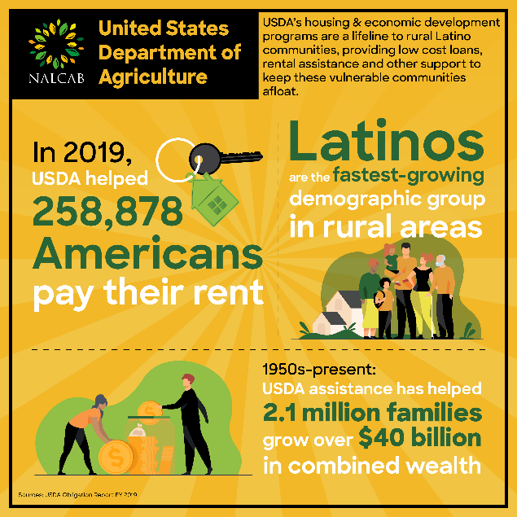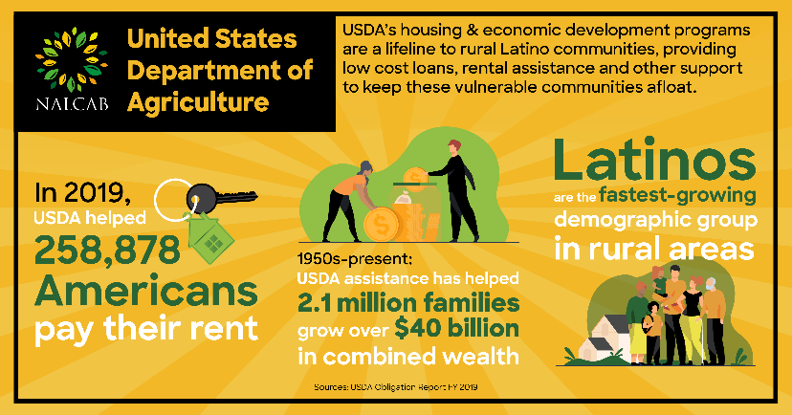

Sample Posts:

Millions of Latinos live in rural communities & face the same affordable housing issues as their urban counterparts. Fully fund the USDA’s Rural Housing & Development programs at $4.2B to keep rural Latinos in safe & secure homes! #LatinoEconomicEngine @NALCAB

Rural small businesses face unique challenges, including geographic isolation & struggles accessing capital. Support Latino entrepreneurs in rural communities by fully funding the USDA’s Rural Housing and Development programs at $4.2B for FY2021! #LatinoEconomicEngine @NALCAB

Broadband access and rural infrastructure have never been more vital than during the COVID-19 crisis. Show up for rural Latinos struggling to access virtual school or work by fully funding the USDA’s Rural Housing and Development programs at $4.2B. #LatinoEconomicEngine @NALCAB

USDA’s affordable housing programs offer assistance to thousands through rental assistance or help building a house from the ground up. Fully fund the USDA’s Rural Housing and Development programs at $4.2B to keep all Americans in homes! #LatinoEconomicEngine @NALCAB

Twitter Handles of US Senators (as of 8/5/2020)

STATE | SENATOR | TWITTER HANDLE
Alabama | Doug Jones | @DougJones
 | Richard Shelby | @SenShelby
Alaska | Lisa Murkowski | @LisaMurkowski
 | Dan Sullivan | @SenDanSullivan
Arizona | Martha McSally | @SenMcSallyAZ
 | Kyrsten Sinema | @SenatorSinema
Arkansas | John Boozman | @JohnBoozman
 | Tom Cotton | @SenTomCotton
California | Dianne Feinstein | @SenFeinstein
 | Kamala Harris | @KamalaHarris
Colorado | Michael Bennet | @SenatorBennet
 | Cory Gardner | @SenCoryGardner
Connecticut | Richard Blumenthal | @SenBlumenthal
 | Chris Murphy | @ChrisMurphyCT
Delaware | Tom Carper | @SenatorCarper
 | Christopher Coons | @ChrisCoons
Florida | Marco Rubio | @MarcoRubio
 | Rick Scott | @SenRickScott
Georgia | Kelly Loeffler | @SenatorLoeffler
 | David Perdue | @SenDavidPerdue
Hawaii | Mazie Hirono | @MazieHirono
 | Brian Schatz | @SenBrianSchatz
Idaho | Mike Crapo | @MikeCrapo
 | Jim Risch | @SenatorRisch
Illinois | Tammy Duckworth | @SenDuckworth
 | Richard Durbin | @SenatorDurbin
Indiana | Mike Braun | @SenatorBraun
 | Todd Young | @SenToddYoung
Iowa | Joni Ernst | @SenJoniErnst
 | Chuck Grassley | @ChuckGrassley
Kansas | Jerry Moran | @JerryMoran
 | Pat Roberts | @SenPatRoberts
Kentucky | Mitch McConnell | @senatemajldr
 | Rand Paul | @RandPaul
Louisiana | Bill Cassidy | @SenBillCassidy
 | John Kennedy | @SenJohnKennedy
Maine | Susan Collins | @SenatorCollins
 | Angus King | @SenAngusKing
Maryland | Benjamin Cardin | @SenatorCardin
 | Chris Van Hollen | @ChrisVanHollen
Massachusetts | Edward Markey | @SenMarkey
 | Elizabeth Warren | @SenWarren
Michigan | Gary Peters | @SenGaryPeters
 | Debbie Stabenow | @SenStabenow
Minnesota | Amy Klobuchar | @SenAmyKlobuchar
 | Tina Smith | @SenTinaSmith
Mississippi | Cindy Hyde-Smith | @SenHydeSmith
 | Roger Wicker | @SenatorWicker
Missouri | Roy Blunt | @RoyBlunt
 | Josh Hawley | @HawleyMO
Montana | Steve Daines | @SteveDaines
 | Jon Tester | @SenatorTester
Nebraska | Deb Fischer | @SenatorFischer
 | Ben Sasse | @SenSasse
Nevada | Catherine Cortez-Masto | @SenCortezMasto
 | Jacky Rosen | @SenJackyRosen
New Hampshire | Margaret Wood Hassan | @SenatorHassan
 | Jeanne Shaheen | @SenatorShaheen
New Jersey | Cory Booker | @SenBooker
 | Robert Menendez | @SenatorMenendez
New Mexico | Martin Heinrich | @MartinHeinrich
 | Tom Udall | @SenatorTomUdall
New York | Charles Schumer | @SenSchumer
 | Kirsten Gillibrand | @SenGillibrand
North Carolina | Richard Burr | @SenatorBurr
 | Thom Tillis | @SenThomTillis
North Dakota | Kevin Cramer | @SenKevinCramer
 | John Hoeven | @SenJohnHoeven
Ohio | Sherrod Brown | @SenSherrodBrown
 | Rob Portman | @SenRobPortman
Oklahoma | James Inhofe | @JimInhofe
 | James Lankford | @SenatorLankford
Oregon | Jeff Merkley | @SenJeffMerkley
 | Ron Wyden | @RonWyden
Pennsylvania | Robert Casey | @SenBobCasey
 | Patrick Toomey | @SenToomey
Rhode Island | Jack Reed | @SenJackReed
 | Sheldon Whitehouse | @SenWhitehouse
South Carolina | Lindsey Graham | @LindseyGrahamSC
 | Tim Scott | @SenatorTimScott
South Dakota | Mike Rounds | @SenatorMikeRounds
 | John Thune | @SenJohnThune
Tennessee | Lamar Alexander | @SenAlexander
 | Marsha Blackburn | @MarshaBlackburn
Texas | John Cornyn | @JohnCornyn
 | Ted Cruz | @SenTedCruz
Utah | Mike Lee | @SenMikeLee
 | Mitt Romney | @SenatorRomney
Vermont | Patrick Leahy | @SenatorLeahy
 | Bernard Sanders | @SenSanders
Virginia | Tim Kaine | @TimKaine
 | Mark Warner | @MarkWarner
Washington | Maria Cantwell | @SenatorCantwell
 | Patty Murray | @PattyMurray
West Virginia | Shelley Moore Capito | @SenCapito
 | Joe Manchin | @Sen_JoeManchin
Wisconsin | Tammy Baldwin | @SenatorBaldwin
 | Ron Johnson | @SenRonJohnson
Wyoming | John Barrasso | @SenJohnBarrasso
 | Michael Enzi | @SenatorEnzi

